## Q-1: ProblemStatement:

Create a registration form for XYZ University. The form should look as shown in the image below.

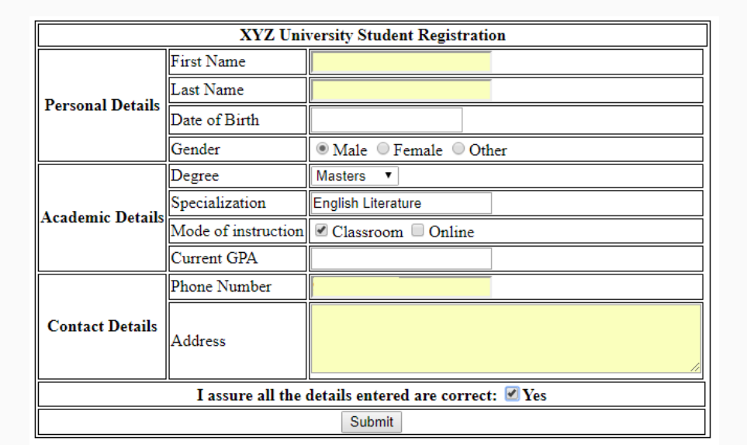

The validations for each field are described below:

* **First Name**: Required, max 10 characters
* **Last Name**: Required, max 10 characters
* **Date of birth**: Required
* **Gender**: Only one option must be selected
* **Degree**: Dropdown should contain "Bachelors", "Masters" and "Doctorate"
* **Specialization**: Required, max 40 characters
* **Current GPA**: Required, max value 5, increment in steps of 0.1
* **Phone Number**: Required
* **Address**: Required, max 4 rows of 40 characters each.

**All required fields should be marked with a red asterisk (*)**

## Q-2: ProblemStatement:

Create the below table for Destiny Tours & Travels price list.

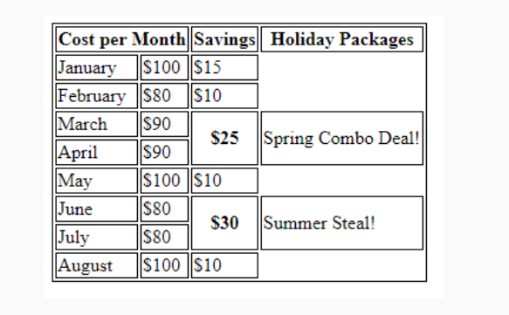

Q-3: ProblemStatement:

Create a form for XYZ online pizza delivery service as shown in the image below.The validations for each field are given below:

* **First Name:**Required, max 20 characters
* **Phone Number**: Required
* **Size**: Required, only one option can be selected
* **Base**: Required, Dropdown should contain "Pan Pizza", "Cheese Crust" and "Chicken Stuffed Crust"
* **Additional details**: contains 2 rows of 30 cols each.

All required fields must be marked with a red asterisk (*)

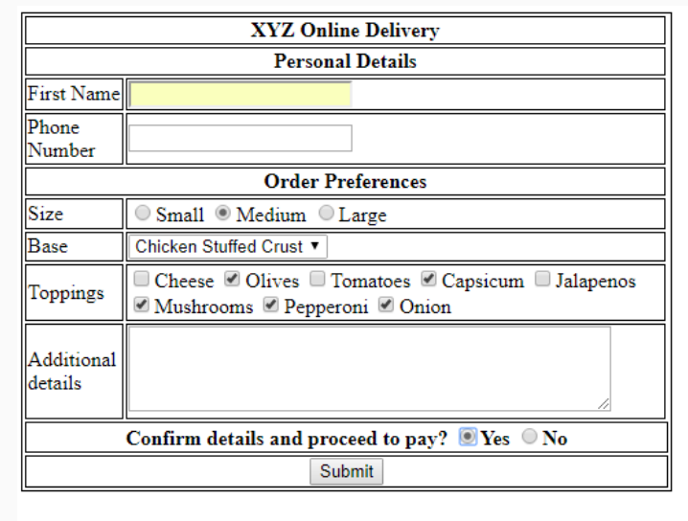

Q-4:PROBLEM STATEMENT – Create the below Form using HTML5 and CSS

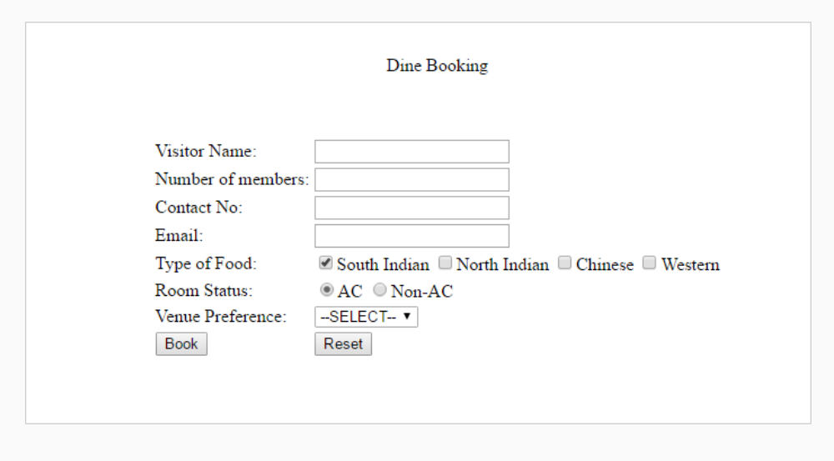

## Q-5: ProblemStatement:

Create the below page using **HTML5 semantic element and CSS3 Flexbox with SASS.**

Note: It should look similar to the page below.

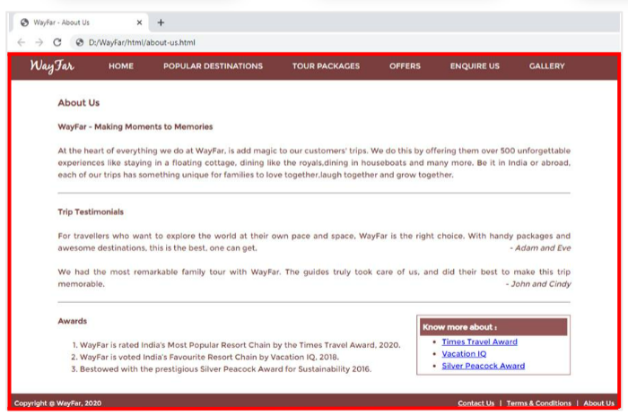

## Q-6: ProblemStatement:

Create the Contact Us page as shown below. Use HTML5,CSS3.

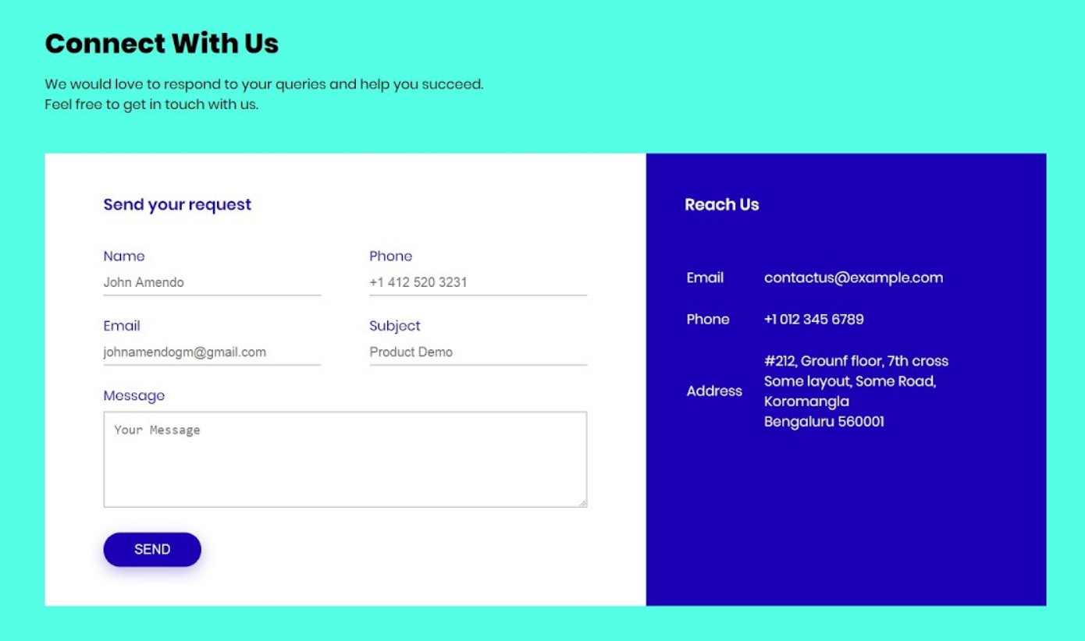

## Q-7: ProblemStatement: Create this page with these 3 cards using HTML5 and CSS3,Box Model,CSS3 Selectors.

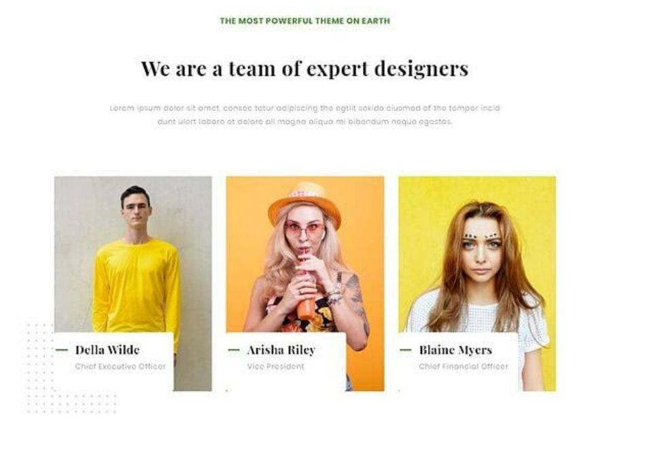

## Q-8: ProblemStatement: Create this page using HTML5 Semantic Elements and CSS3 Flexbox, Layout, Combinators,,Gradient.

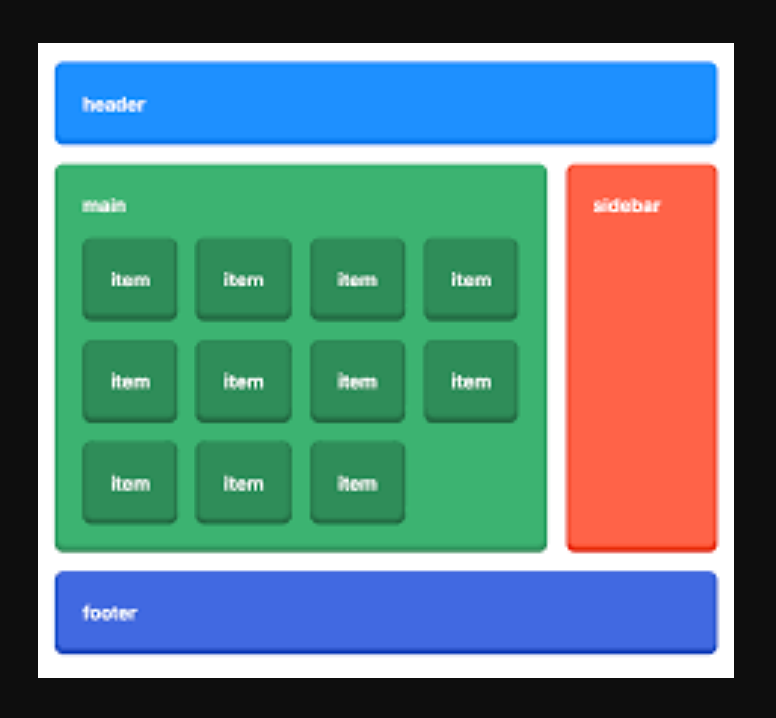

## Q-11: ProblemStatement:

**1. home.html**

This page renders the information about the company. It has a ‘Explore More’ button when clicked should take the user to services.html**. Here : Use Html5 Semantic Elements,CSS3 Selectors, Flexible Layout, Flexible images. Use SASS (CSS Preprocessor)**

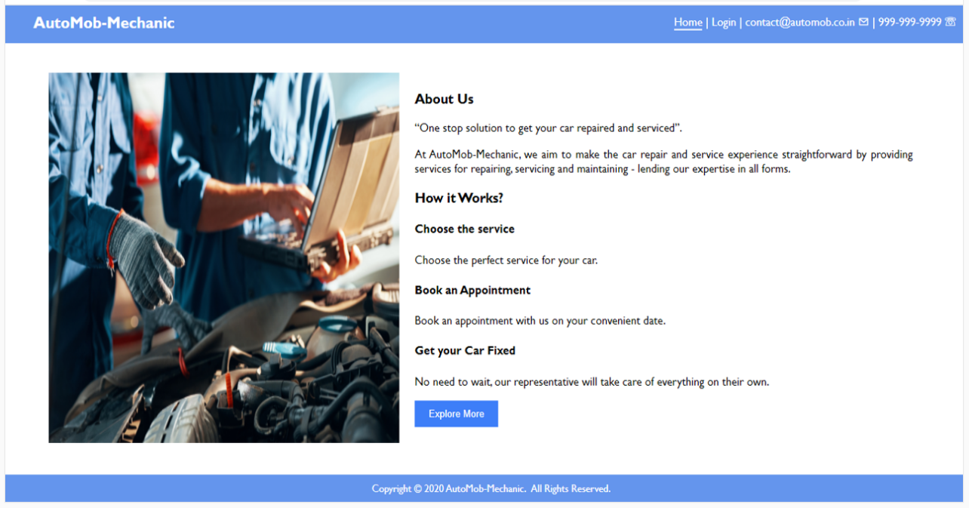

2.Services.html : Here you have to display the content as it is.

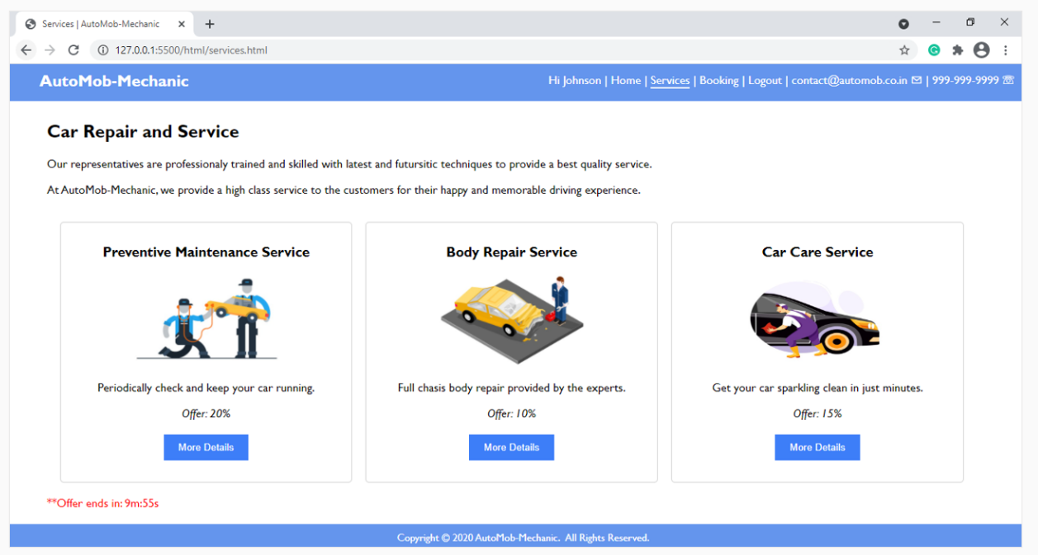

3. Reports.html – This page will render a table .

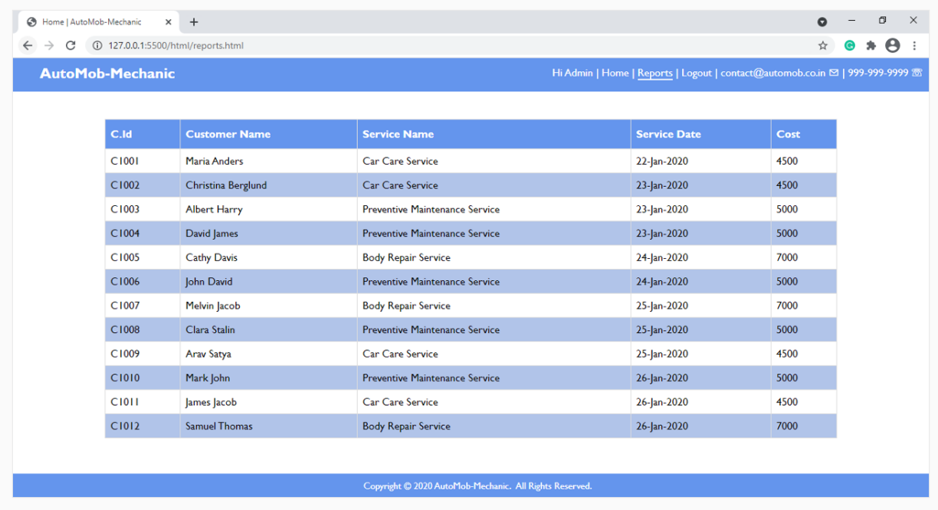

12. Create an UI with **HTML5,CSS3.**

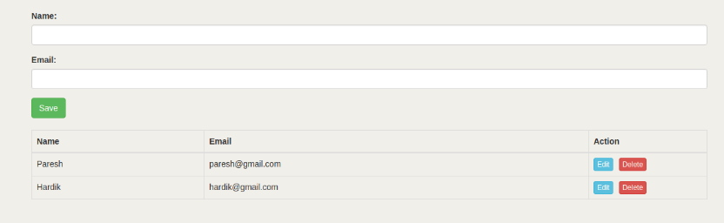

13. Create the calculator using **Html5,Css3 .**.

